**Unit 2 Exam Review: Tools of Geometry on the Coordinate Plane**

Midpoint and Distance

1. FG has endpoints *F* (−2, 3) and *G* (1, 1). What are the coordinates of its midpoint?
2. M is the midpoint of *AB* and is located at M(3, 5). A is located at A(1,2). What is the coordinate of the other endpoint, B?
3. In radical form, what is the distance between points *D* (32, 4) and *E*(20, 8)?
4. QR has endpoints *Q* (9, −2) and *R* (3, 5).
   1. What are the coordinates of its midpoint *X?*
   2. What is the length of QR, in radical form?

Directed Line Segments

Line segment XZ has endpoints X(-4,5) and Y(6,10). Point Y is on XZ such that XY:YZ is 2:3. What are the coordinates of point Y?

[*The use of the set of axes is optional]*

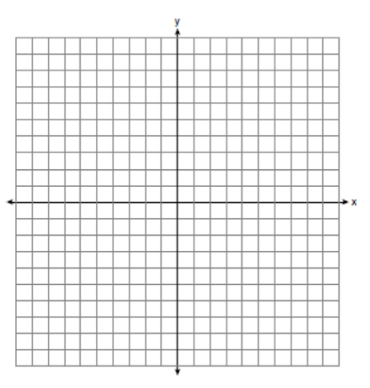

Equations of Lines

**Use the given information to write the equation of the line.**

1. slope  and *y*-intercept 4
2. passes through (0, 3) and (1, 4)

Parallel and Perpendicular Lines

**Find the slope of  and *.* Then determine whether  and  are *parallel, perpendicular,* or *neither.* Explain.**

**11.** *L*(10, 2), *M*(6, –6), *Q*(10, 6), *R*(9, 4)

**12.** *L*(–3, 8), *M*(2, –7), *Q*(14, 16), *R*(10, 4)

**13.** What is the equation of the line parallel to *y* = *x* − 1 that contains the point (1, 2)?

**14.** What is the equation of the line perpendicular to  that contains the point   
(−2, 1)?

Spiral Review – Two Parallel Lines cut by a Transversal

1. 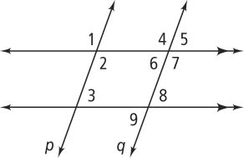Name a pair of the following type of angles:
   1. Corresponding
   2. Alternate interior
   3. Vertical
   4. Same-side interior
   5. Same-side exterior

**5.** *m*∠2 = 50 and *m*∠3 = _______ ? **6.** *m*∠4 = 100 and *m*∠2 = _________ ?

**7.** *m*∠1 = 75 and *m*∠3 = _________ ? **8.** *m*∠5 = 110 and *m*∠8 = __________ ?